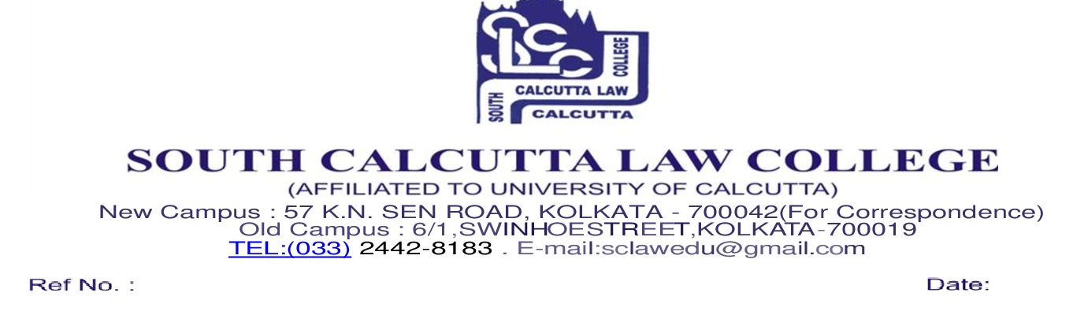
NOTICE
Date - 11/01/2022

All the students of South Calcutta Law College are hereby informed to follow the college website regarding the routine and instructions of the fourth coming on-line External Examination 2021 B.A. LL.B. 5 years General & Honours Examination;

Routine of 3rd, 5th, 7th and 9th Semester which is scheduled to be held from 15.01.2022 to 28.01.2022 Instruction

All the students have to upload their answer scripts on the following mail ID. Students should upload their answer script in compact PDF/JPG format through the following instruction :

- In the front page of the answer scripts the students of 3rd, 5th, 7th & 9th Semester have to mention

- University Roll No
- University Registration No
- Name of the subject and Paper number
- Name of the Examination
- Page numbering of answer scripts is compulsory
- Students have to write their University Roll No in each page of their answer scripts properly
- PDF file name of the student should be University Roll Number
- Supplementary candidate must mention in his/her front page of the answer script the word ‘supplementary’

- Answer scripts should be clearly visible
- Pages should not be rotated horizontally
- PDF size should be less than 8 – 10 mb
- PDF file pages should be sequentially arranged according to page number
- Try to answer your question in order
- Handwritten or typed answer scripts are also allowed

Mail IDs along with the date, semester, subject are as follows (Time – 10.00 a.m. to 5.00 p.m. )

Sl No | Name of the Subject | Paper | E-mail ID | Semester
1 | Political Science-III | I | politicalsc3rd@gmail.com | 3rd semester
2 | Sociology-III | II | 3rdsemsocio@gmail.com | 3rd semester
3 | Economics-I | III | 3rdeconomics@gmail.com | 3rd semester
4 | Legal Method | IV | legalmethod3rd@gmail.com | 3rd semester
5 | Law of Torts including MVA and CP Law | V | torts3rd@gmail.com | 3rd semester
6 | Political Science-V | I | polsc5th@gmail.com | 5th semester
7 | Economics-III | II | 5thsemeconomics@gmail.com | 5th semester
8 | Constitutional Law-II | III | constitutionallaw5th@gmail.com | 5th semester
9 | Administrative Law | IV | admnlawth5@gmail.com | 5th semester
10 | Property Law | V | propertylaw5th@gmail.com | 5th semester
11 | Jurisprudence | I | jurisprudence7th@gmail.com | 7th semester
12 | Public International Law | II | pubintlaw7th@gmail.com | 7th semester
13 | Banking Law | III | bankinglaw7th@gmail.com | 7th semester
14 | Law of Evidence | IV | 7evidencest@gmail.com | 7th semester
15 | Patent Right Creation and ROP | I | patentrightshons@gmail.com | 7th semester (Honours)
16 | International Trade Economics | II | inttradeeco@gmail.com | 7th semester (Honours)
17 | Company Law | I | companylaw9th@gmail.com | 9th semester
18 | Information Technology Law | II | itlaw9th@gmail.com | 9th semester
19 | Labour and Industrial Laws-II | III | labourlaw9th@gmail.com | 9th semester
20 | Taxation Law | IV | taxation9th@gmail.com | 9th semester
21 | Corporate Governance | I | corpgovhons@gmail.com | 9th semester (Honours)
22 | Probation and Parole | II | probationparolehons@gmail.com | 9th semester (Honours)
