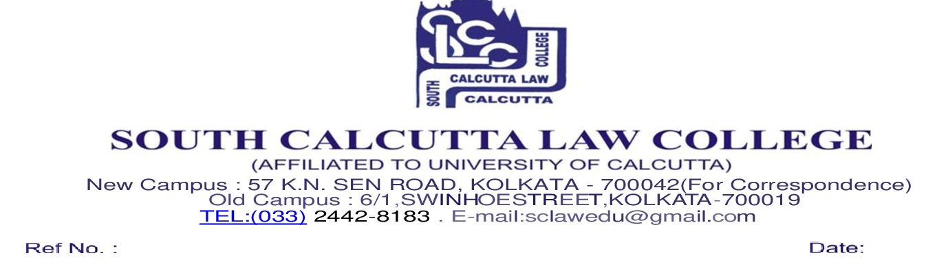
M NOTICE
Date – 1/05/2021

It is hereby notified that following listed Honours candidates 2020–2021 are directed to submit the Application for Admission along with Documents through College e-mail address : sclawedu@gmail.com and Admission Fees via online process through College Bank Account on 4th May, 2021 (Tuesday), 5th May, 2021 (Wednesday) and 6th May, 2021 (Thursday) from 10.00 a.m. to 02.00 p.m. Home Students need to pay Rs.3,000/- (Rupees Three Thousand only) for Admission Fees and Outside Candidates of Other Colleges need to pay Rs. 17,060/- (Rupees Seventeen Thousand and Sixty only) for Admission Fees & Rs.300/- X 6 = Rs.1,800/- (Rupees One Thousand and Eight Hundred only) per month tuition fees w.e.f. July, 2021

Bank Details for payment regarding Admission are as follows :

- Bank Name : State Bank of India
- IFSC Code : SBIN0000018
- Bank Account No : 39144468364
- Name of the College : SOUTH CALCUTTA LAW COLLEGE

Scanned Copy of Students (both Home and Outside) Documents are required to be
submitted online through College e-mail address : sclawedu@gmail.com are given below :

- All Semester Mark Sheet
- C.U. Admit
- C.U. Registration Certificate
- Transfer Certificate (for outside candidates of Outside College)
- Aadhaar Card
- Payment Slip

