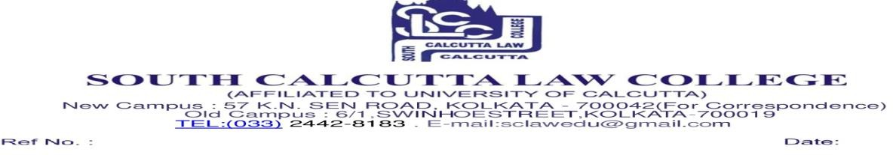

Online Class Routine
Time Slot: 8:00 AM to 9:00 AM

1st Semester B.A.LL.B.
Date | Day | Subject | Faculty | Google meet link
08/05/2026 | Friday | Sociology - I | S.D. | https://meet.google.com/xvz-cqfi-cnd
11/05/2026 | Monday | Political Science - I | S.D. | https://meet.google.com/yba-mrmw-esg  Or open Meet and enter this code: yba-mrmw-esg
12/05/2026 | Tuesday | Hindu Law | A.K.P. | https://meet.google.com/mhb-xfqa-mje  Or open Meet and enter this code: mhb-xfqa-mje
13/05/2026 | Wednesday | Law of Contract - I | S.S.R. | https://meet.google.com/kpa-zncf-nhn  Or open Meet and enter this code: kpa-zncf-nhn
14/05/2026 | Thursday | English - I | A.M. | https://meet.google.com/xvz-cqfi-cnd
15/05/2026 | Friday | Law of Contract - I | G.L. | https://meet.google.com/umy-eyuu-ysn  Or open Meet and enter this code: umy-eyuu-ysn

S/d
Vice Principal

