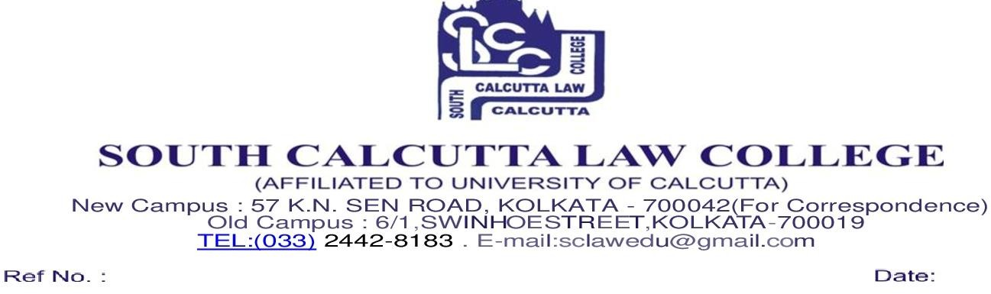

NOTICE
21/04/2026

This is to inform all students of the 1st Semester that the examination form fill-up process has been temporarily withheld. Due to the non-receipt of the official examination forms from the University of Calcutta, the college is currently unable to proceed with the scheduled dates. Please be assured that we are in constant communication with the University regarding this matter.

Date of Form Fill up of 1st semester will be informed later on after receiving information from the University of Calcutta.

Students are advised to check the college notice board and website regularly for further updates.

By order
Dr. Nayna Chatterji
Vice Principal

