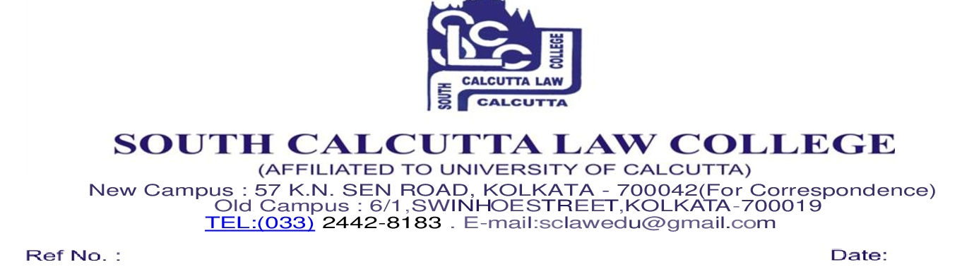
NOTICE
Date - 21/11/2025

All the candidates who have been enlisted and have done their admission on-line for 3rd Phase admission on-line process (session 2025-2026) in South Calcutta Law College are hereby informed to bring with the following documents original and photocopies both on 24th November, 2025, Moday from 9.30 a.m. to 11.00 p.m. at 57 K. N. Sen Road, Kolkata–700042 (near Bijon Setu and Beside Dolna school).

- Receipt of Seat Booking Fess of Rs. 2000/-
- Receipt of Admission Fess of Rs. 14105/-
- Downloaded admission form of South Calcutta Law College
- Admit Card of Class X & XII passed Examination
- Mark Sheet of H.S.(10+2)
- 3 copies of stamp size photos of the candidate
- SC,ST,OBC,P.H., EWS Certificate (If applicable)
- DOMICILE CERTIFICATE
- EQUIVALENCE CERTIFICATE
- CULET Application form
- Date of Birth Certificate
- Downloaded Admission slip issued by University of Calcutta
- C.U. Registration No if any
- Signed Anti Ragging and Self Declaration form
- Aadhaar Card

N.B. : (1) No candidates will be entertained for admission after the
Scheduled date and time.

Dr. Nayna Chatterji
Vice Principal

