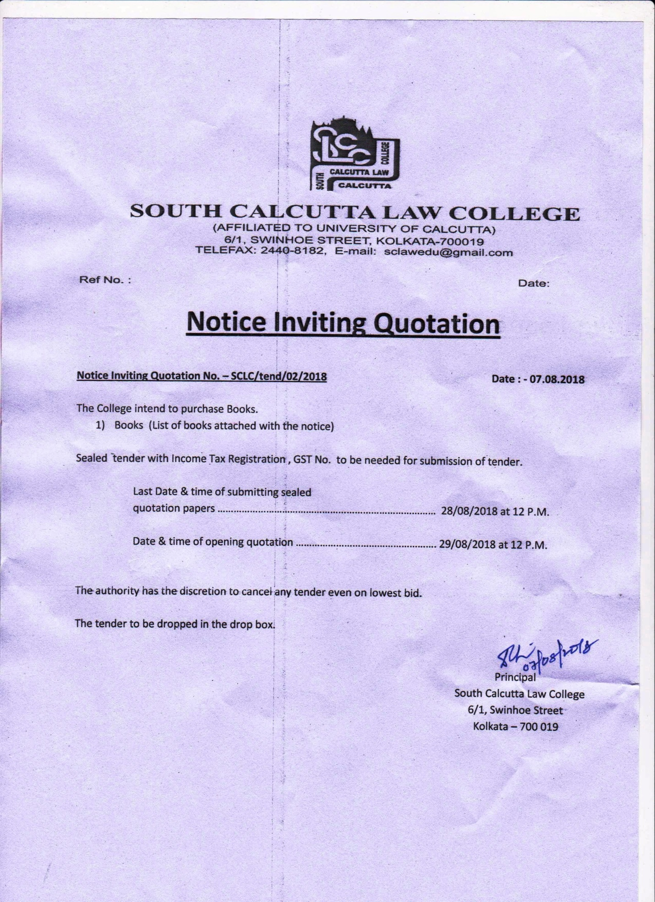
BOOK NAME |  | AUTHUR
- Labour Law(manual)
- Insurance Law |  | Srinivasa, murthy
- Women on the edge of progress reflections from third world counties |  | Prabhat kr Sing & Amit Bhowmik
- Gender perspectives from global lens. |  | Prabhat kr Sing & Amit Bhowmik
- Juvenile system in india |  | Ved Kumari
- Law relating to juvenile system in India |  | R.N. Chowdhuri
- Law Relating to gender inequality political Rights in India. |  | Fall.Agenis
- Gender Justice Women Law in India |  | Monica chawla
- Feminism in India |  | Maitrayee Chawdhury
- Towards Gender Justice |  | S.P.Sathe
- Corporate governance emerging Concerns |  | Shasinath Mondal & Bhupal Bhattacharya
- Law & Practice Intellectual Property in India |  | Vikash Vashist
- Intellectual Property law |  | V.k Ahuja
- International trade Economics antidumping under GATT laws |  | Sheela Rai
- International trade law |  | Ishita Chatterjee
- International Trade Economy. |  | A.K. Kaur
- Human rights (tracking of women & children legal & policy frame work) |  | Usha tandom & Sidharth
- Mercantile law |  | N.D.Kapour
- Administrative Law |  | C.K.Takwani, U.p. Kesari, I.P. Messi, J.N. Upadhyay
- Child rights the law |  | Dr.Nuzat, parveen Khan
- Insurance Law |  | Avtar Singh
- Jurisprudence the philosophy & method of Law |  | Edgar bodenheimer
- Principals of insurance Law |  | Peter n.Swisher
- Sarkar’s Trademarked & practice
- Indian Constitution |  | Narender kumer, M.P.Singh, H.m.Seervai (vol)
- Black law Dictionary |  | Bryan A. garner
- Indian Panel code, Criminal procedure |  | S.n.Mishra
- Administrative law |  | Katsee
- Prisons of Banking Financial services in India |  | Sumit Gupta, vinay kandtal, P.C.Kavidayal.
- Law & social trans formation |  | Ishwara bhatt
- Human Rights |  | Jatinder Kumar Das
- Starks international law
- Interpretation of statues |  | N.S. Bindra & G.p.singh
- Muslim law |  | R.K.Sinha
- Partnership law |  | S.C.Tripathi
- Judicial Service examination |  | Gupta(universal), M.A.rashid
- UGC Net |  | Lexisnexic
- India’s living constitution |  | Sridharan, R. Sudershan
- Dias Jurisprudence
- High Court Rules & order
- High court original site rules Appellate site rules
- Civil Procedure Code |  | Mulla, Sukumar ray
- Environmental law |  | Pleela Krishna, p. s jaiswal
- Land Laws bare act
- West Bengal land reforms, premises tenancy, apartment ownership Act.
- Land Law |  | S.n. Mishra
- Research methodology |  | Enwarul Yakin
- Business law |  | Kindra publications
- Indian Panel code |  | M.a. Rashid
- Companies Act 2013 |  | Bare act
- Environmental Law an fomenting issues |  | Alok Pandey
- Criminal Procedure |  | Sukumar Ray
- The law of Partnership |  | P.c.markanda
- Ramaiya’s Company Law |  | New Edition
- Judicial Activism & pil |  | S.P Sathe
- Jurisprudence |  | Liyod
- Jurisprudence |  | Pranjapee
- Judicial process |  | Cardazo
- Women & Child Trafficking In India |  | Rekha roy
- Law of contract (Combined Book) I & II |  | s.s.srivastava
- Judicial process |  | G.B. Tripathi
- Envirmantal law |  | Kailash rai
- Law of equity |  | B.M.Gandhi
- Intellectual Property rights |  | Jayashree wata
- Limitation act |  | Prem Agarwal
- Environmental law |  | Rocen Cranz
- Code of Civil Procedure |  | J.K.Das
- Limitation act |  | H.P.Gupta
- Transfer of Property |  | S.N.Shukala
- Transfer of Property |  | R.K.Sinha
- Transfer of Property |  | Mulla
- Copy Right law |  | J.K.Das
- Indian Divorce Act |  | Text Book
- Indian Succession act |  | Justice K Kannan
- Probation and prude |  | S.R.Myneni
- Law of Tort |  | S.S.Chatterjee
- Information technology |  | Pawan Duggal
- Information technology |  | Janathan Cloogh
- Information technology |  | Aparna Vishwanatha
- Law of Social Information |  | Mallick & Rawal
- Banking law |  | Tanna’s
- Banking law |  | Anjani kant
- Media law |  | Sukanta K.Nanda
- Moot court |  | Kailash Rai & Dzooza
- Taxation Law |  | Atal Kumar
- Techno legal aspects of scientific evidence |  | Ishita Chatterjee
- Victinology & compensatory jurisprudence |  | G.S.Randhawa
- Administrative law |  | Yasomati Ghosh
- Company Law |  | G.K.Kapour & Sanjay Dhamija
- Systemic approach in India |  | Chetan Gandhi
- Law & Medicine |  | Bodhis
- Competition law |  | S.C.Tripathi
- Comparative Constitution |  | M.P.Singh
- Administrative Law |  | C.K.Thakker
- Due process of Law |  | Abhinav
- Principal of Criminal law |  | K.l vibhute
- Morality in Law |  | D.P.Singh
- Liberty Equality Justice |  | S.P.Sathe
- Indian Panel Code |  | S.S.Chatterjee
- Equal justice & foretimes |  | V.R.Krishnalyya
- Human Rights in India |  | B.P.Sahgal
- Sports of Midia |  | Lovely Dasgupta
- Human Rights & Social Justice |  | Gokholesh lama
- Judicial Power & Process |  | Aniruddha Prasad
- Sports Law Regulation |  | Mathew Mitten
- Corporate finance |  | Pearson
- Fundamental of corporate finace |  | Jonathan Berk
- Corporate finance |  | Peter demarzo
- Corporate governance |  | Subhash Chandra Das
- Jurisprudence |  | Namita Agarwal
- Women & Criminal law |  | Dr.S.C.Trapathi
- Modern Hindu Law |  | U.P.Dkesani
- Women & Children |  | S.C.Trapathi
- Guide to the Witco & GATT Economic Law & Politic |  | A.K.Kowel
- Enivermantal law |  | Bare Act
- Land Law |  | Bare Act

