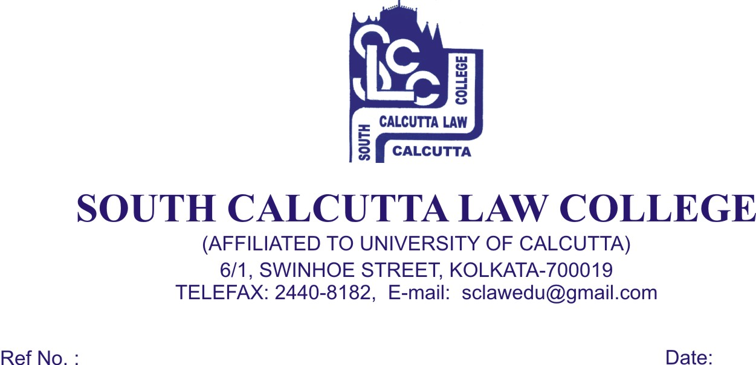
NOTICE
Date - 17 /07/2019

All the candidates who have been enlisted for B.A.LL.B. 2nd phase admission (session 2019-2020) in South Calcutta Law College are hereby informed to bring with the following documents original and photocopies both on 18th July, 2019, Thursday, 19th July, 2019, Friday , and, 22th July, 2019,Monday from 9.00 a.m. to 11.00 a.m. No candidate will be entertained for admission after the scheduled date and time.

- Admit Card of Class X & XII passed Examination
- Mark Sheet of H.S.
- 2 copies of stamp size photos of the candidate
- SC/ST Certificate
- P.H. Certificate
- Date of Birth Certificate
- Downloaded Admission slip & B.A. LL.B Entrance Test Admit Card
- AADHAR card
- C.U. Registration No. if any

At the time of Admission the candidate will pay Rs. 14,360/- (Rupees Fourteen Thousand Three Hundred and Sixty) only in cash.

If he/she wishes to clear Annual fees, he/she has to give Rs.15,620/- (Fifteen Thousand Six Hundred and Twenty) only in cash.

By Order

Dr. Nabamita Paul Ray
Teacher-in-Charge
South Calcutta Law College

