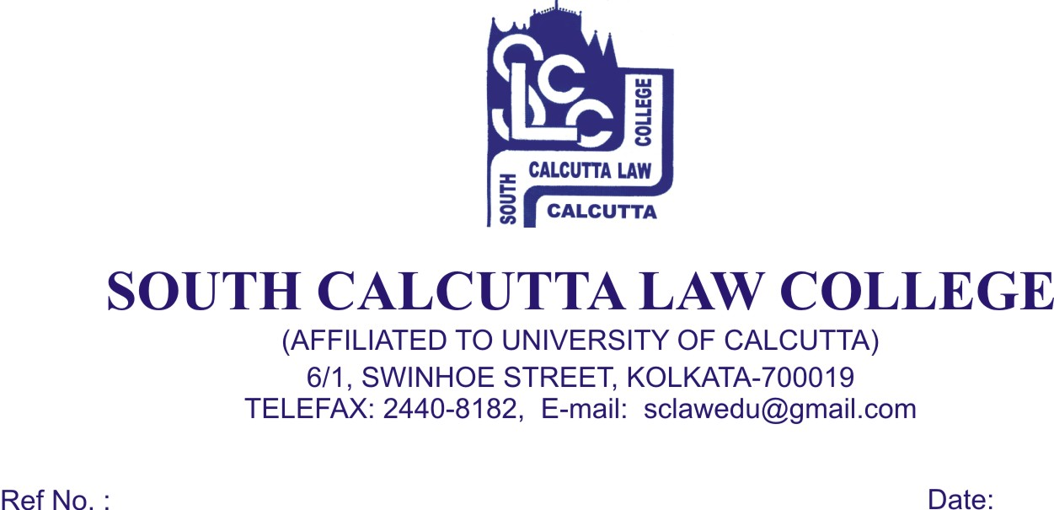
NOTICE

Date - 17 /04/2019

All the candidates who have been enlisted for admission in LLM (session 2018-2019) are hereby informed that admission to the said course will take place on 24thApril ,2019, Wednesday, 25thApril, 2019, Thursday from 9.00 a.m. to 11.00 a.m. they are required to bring the original and photocopies of the following documents. No candidate will be entertained for admission after the scheduled date and time.

- Admit Card of Class X & XII passed Examination
- Mark Sheet of H.S.(10+2) , and B.A.LL.B final mark sheet.
- 2 copies of stamp size photos of the candidate
- SC/ST Certificate
- Migration Certificate
- Date of Birth Certificate
- LL.M Entrance Test Admit Card (Original)
- Bill of Rs. 2000/- (paid at the time of Counseling)
- Aadhaar Card

At the time of Admission the candidate will pay Rs. 8,000/- (Rupees Eight Thousand) only in cash.

Total fees for LL.M. first year is Rs. 10,000/- (Ten Thousand only)

By Order

Dr. Nabamita Paul Ray

Teacher-in-Charge
South Calcutta Law College

