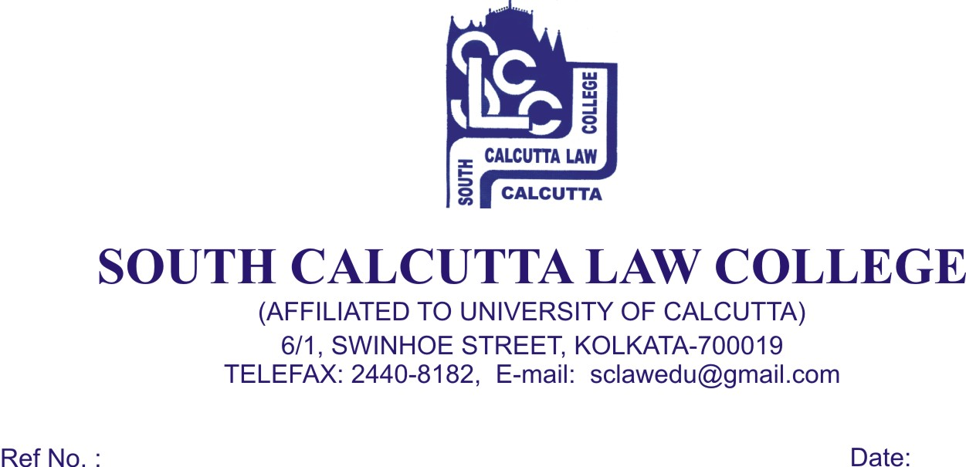
NOTICE
Date – 03/10/2018

College will remain closed on 8th October, 2018, Monday on the occasion of Mahalaya.

College will remain closed from 13th October, 2018, Saturday to 10th November, 2018 Saturday on the occasion of Puja Vacation (Durga Puja, Laxmi Puja, Kali Puja, Diwali and Bhatridwitiya) and will re-open on 12th November, 2018 Monday.

All Teaching, Non – Teaching, Library Staff & Casual Staff are hereby informed that College will remain open on the following days during the Puja Holidays from 9.00 a.m. to 12.00 p.m. :

(i) 30.10.2018 (Tuesday)
(ii) 02.11.2018 (Friday)

Dr. Debasis Chattopadhyay
Principal

