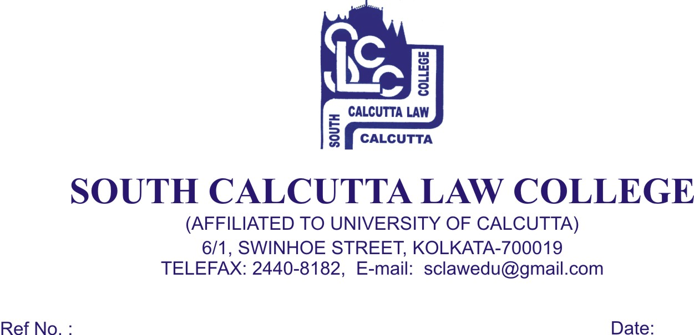
NOTICE

Date – 30/08/ 2018

Students of 1st (First) Semester (Admission 2018) are hereby informed to apply for their C.U. Registration Forms from the New Campus College Office of South Calcutta Law College, 57 K.N.Sen Road, Kolkata - 700 042 immediately on 4th September, 2018, Tuesday and 5th September, 2018, Wednesday from 09.00a.m. to 11.00 a.m. along with these following documents :

- Photocopy of Admit Card of B.A.LL.B. entrance test, 2018
- Photocopy of H.S. (10+2) Admit Card
- Photocopy of H.S. (10+2) Mark Sheet
- Photocopy of Madhyamik Admit Card for Date of Birth proof
- Two (2) stamp size photo
- In case of Migration Students, Original Migration Certificate is required
- Photocopy of S.C., S.T., O.B.C., and P.W.D. Certificate
- Photocopy of Aadhaar Card
- Photocopy of BPL/APL card

- Registration Fees (Non – Migration) ----- Rs. 250/- (Rupees Two Hundred and Fifty) only
- Registration Fees (Migration) ----- Rs. 350/- (Rupees Three Hundred and Fifty) only

Students are also required to mentioned their Joint entrance 2018 Roll No and Rank on all their photocopies.

Registration Form and Migration Form will be collected from the New Campus Office of South Calcutta Law College, 57 K.N.Sen Road, Kolkata - 700 042

Dr. Debasis Chattopadhyay
Principal

