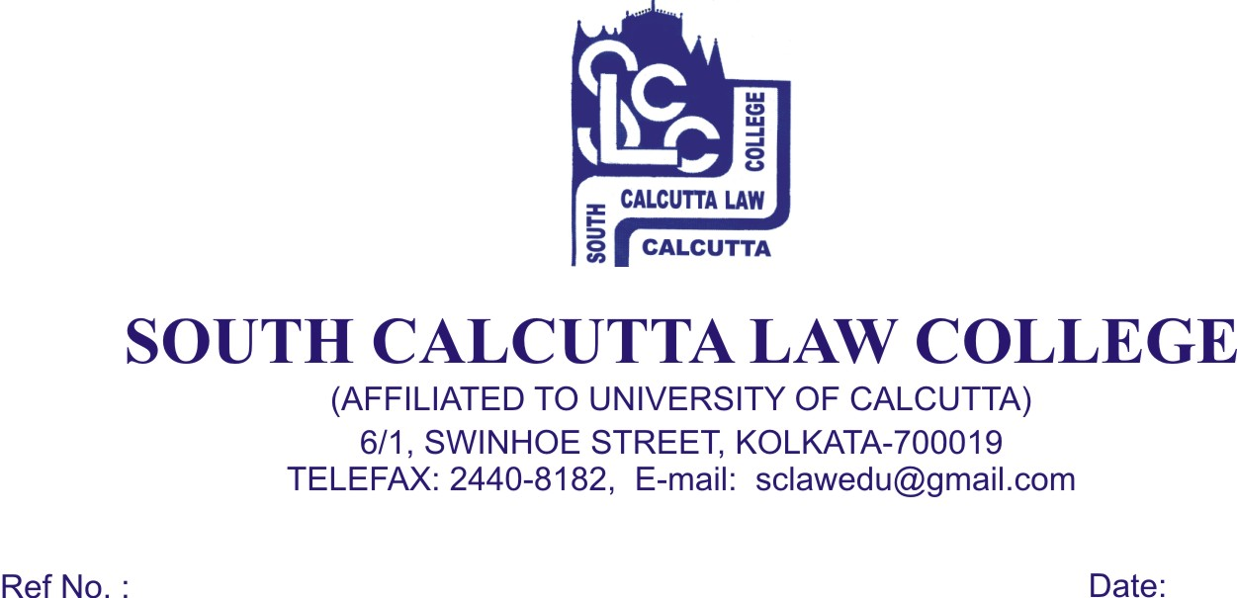
NOTICE
Date - 14.08.2018

Students of 1st (First) semester (Admission 2018) are hereby informed that a meeting will be held on 16th August, 2018 (Thursday) at 11.00 a.m. at New Campus 57 K.N. Sen Road Kolkata – 700 042 with Principal Sir and the guardian of all the Students of 1st (First) semester.

Your presence and co-operation is utmost solicited.

Dr. Nabamita Paul Ray
Lecturer-in-Charge
South Calcutta Law College

