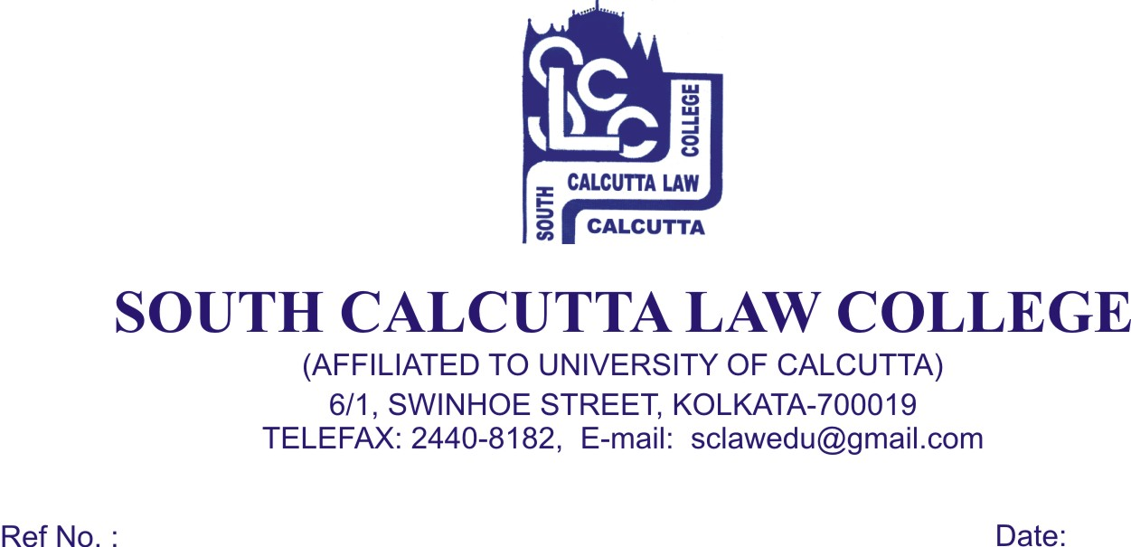
NOTICE
Date - 27 /07/2018

All the candidates who have been enlisted for admission (session 2018-2019) in South Calcutta Law College are hereby informed to bring with the following documents original and photocopies both on 28th July, 2018, Saturday, 30th July, 2018, Monday and 31th July, 2018,Tueday from 9.00 a.m. to 11.00 a.m. No candidate will be entertained for admission after the scheduled date and time.

- Admit Card of Class X & XII passed Examination
- Mark Sheet of H.S.
- 2 copies of stamp size photos of the candidate
- SC/ST Certificate
- P.H. Certificate
- Date of Birth Certificate
- Downloaded Admission slip & B.A. LL.B Entrance Test Admit Card
- AADHAR card

At the time of Admission the candidate will pay Rs. 19,000/- (Rupees Nineteen Thousand) only in cash.

If he/she wishes to clear Annual fees, he/she has to give Rs.20,290/- (Twenty Thousand Two Hundred and Ninety) only.

Certificate Courses

Online certificate course will be provided to the students which will be conducted by South Calcutta Law College. The course details are given below :

- Intellectual Property : Law and Management
- Cyber Law and Practice
- Advanced Contract Drafting
- Social Media and the Information Technology Act
- Advanced Entrepreneurship Management and Corporate Laws

- Fundamental Learning, Ideas, Inspiration and Practical Advice
- Optional Interactive Sessions
- Learn with and Challenge The Experts
- Professional Learning Techniques
- High Quality Supplemental Study Material
- Online Pre – Recorded Lectures
- Podcasts from Practicing Lawyers
- Animated Videos
- Each Course is for Rs. 3,000/- (Rupees Three Thousand) only

Dr. Nabamita Paul Ray
Lecturer-in-Charge
South Calcutta Law College

