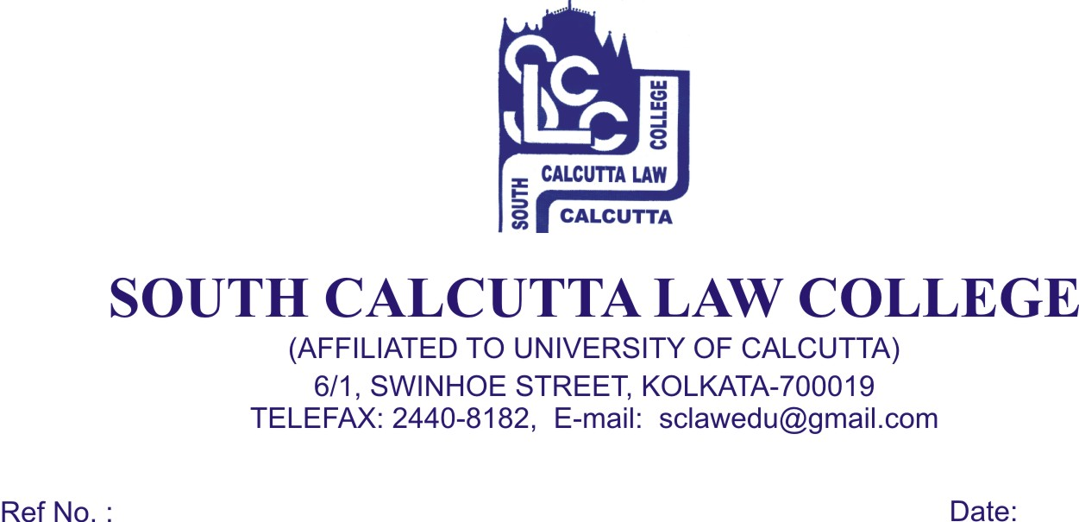

NOTICE
Date – 28/07/2018

Students of 1st Semester, 3rd Semester, 5th Semester, 7th Semester,9th Semister and Honours. and General Candidates of B.A.LL.B (5 year course), Examination, 2018 are hereby notified that Mark sheets will be issued on 30th July , 2018 (Monday) to 31th July, 2018 (Tuesday) from 09.00a.m. to 11.30 a.m. respectively.

All students are required to bring the ADMIT CARD and FEES CARD.

No Candidates will be entertained
after the above mentioned dates.

Dr. Debasis Chattopadhyay
Principal

