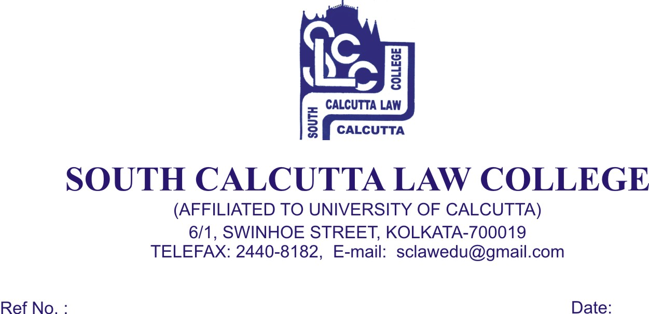
NOTICE
Date - 11/07/2018

College will remain closed on 14th July, 2018, Saturday on account of RATHA YATRA and re – open on 16th July, 2018, Monday.

Dr. Nabamita Paul Ray
Lecturer-in-Charge
South Calcutta Law College

