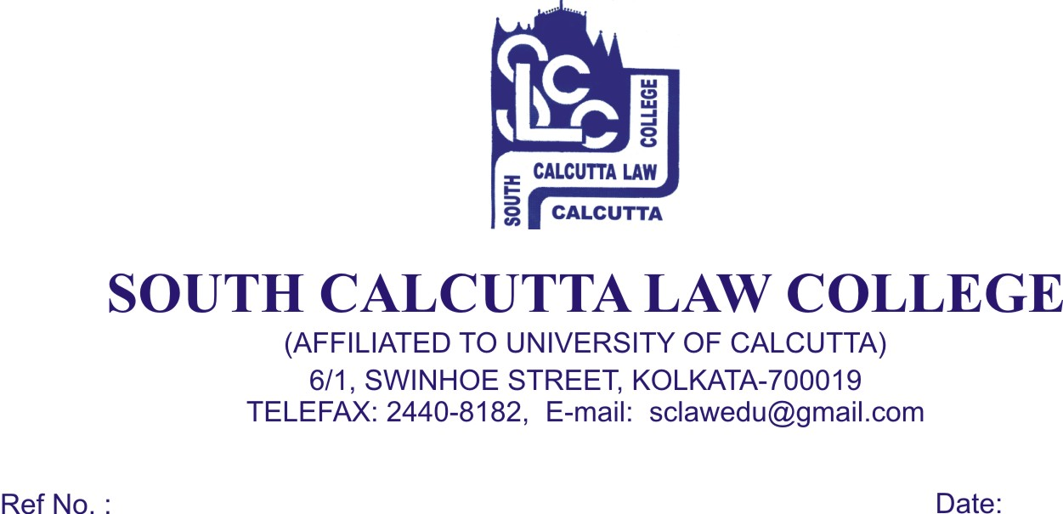

NOTICE
Date – 13/06/2018

All Honours students of 6th and 8th semesters are hereby informed
that their Honours Classes cannot be started from 21.06.2018 due
to unavoidable circumstances. The date of commencement of the
Honours Classes will be notified later.

Dr. Debasis Chattopadhyay
Principal

