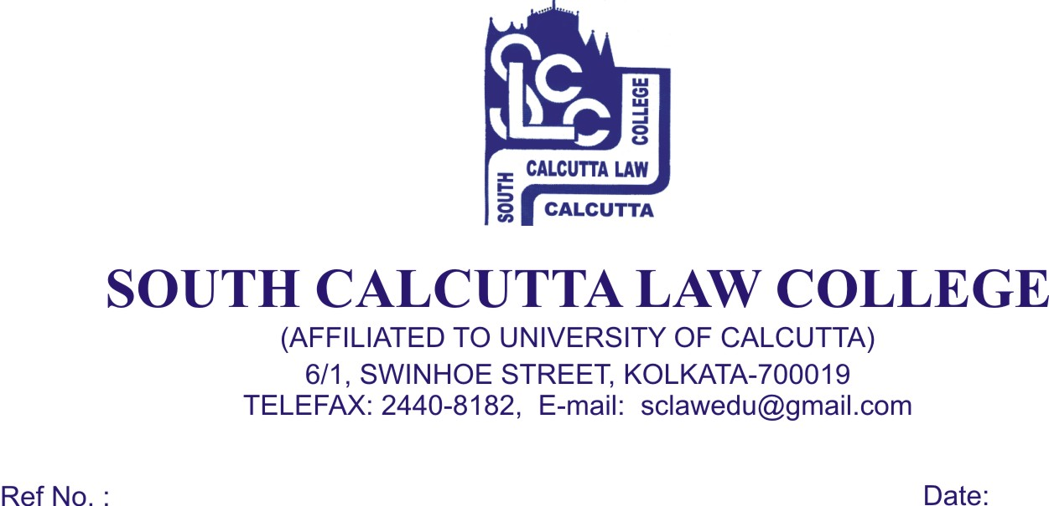
NOTICE
Date – 13/06/2018

Students of all semesters are hereby informed that their classes will remain suspended on 14.06.2018 due to an Iftar Party to be held on 13.06.2018.

Dr. Debasis Chattopadhyay
Principal

