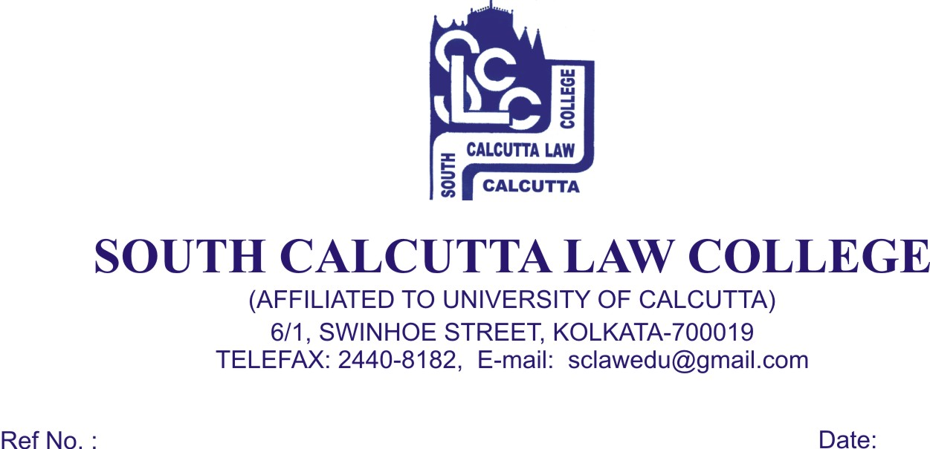 NOTICE
Date – 12/05/2018

Students of 10th (Tenth) Semester are hereby informed to collect the “practical khata” & “diary” from the office only on 24.05.2018 (Thursday) from 9.30 a.m. to 11.30 a.m. along with the Fees Card. The cost of “practical khata” & “diary” is Rs. 500 (Rupees Five Hundred) only. You are directed to submit the “practical khata” & “diary” to Mr. Abhijit Mukhopadhyay and Mr. Somenath Mukherjee along with the photocopy of money receipt.

***Students need to clear the Fees till May, 2018***

N.B. : No Students will be entertained after
the above mentioned date regarding “practical khata” & “diary”

Dr. Debasis Chattopadhyay
Principal

