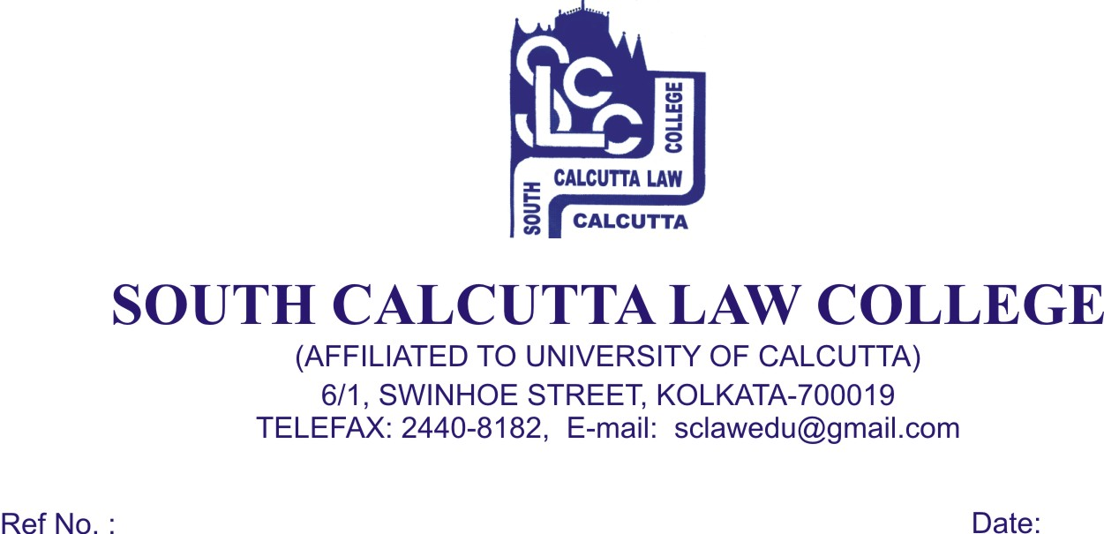
NOTICE
Date – 23/04/2018

College will remain closed on 30th April, 2018, Monday and 1st MAY, 2018, Tuesday on account of “Buddha Jayanti” and “International Workers' Day” and re – open on 2nd MAY, 2018, Wednesday.

Dr. Debasis Chattopadhyay
Principal

