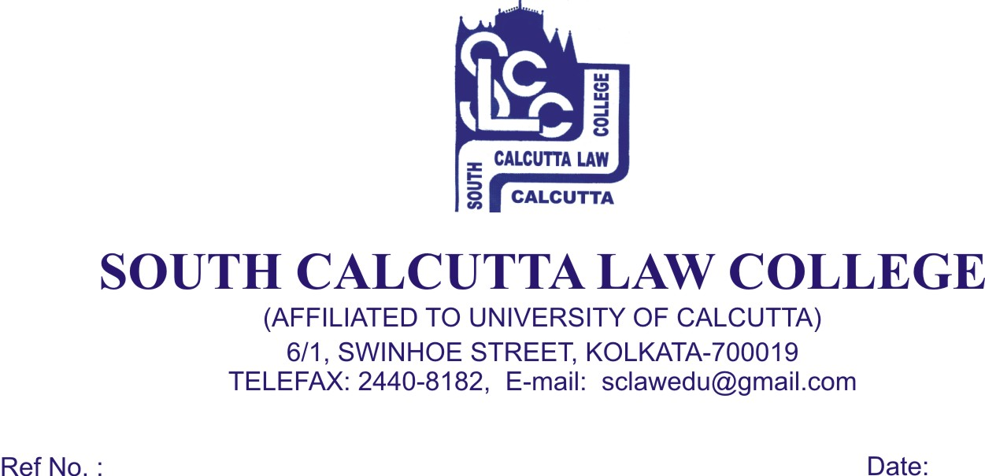

NOTICE
Date - 26/03/2018

Students of 3rd, Semester Candidates B.A.LL.B (5 years course), General. Examination, 2017 are hereby informed that Admit Card will be issued on 27.03.2018 (Tuesday) and 28.03.2018 (Wednesday) from 09.00 a.m. to 12.00p.m.

The above dates which are finalized for issuance of Admit Card are mandatory.

No Candidates will be entertained after 27.03.2018 (Tuesday) and without the ‘FEES CARD’.
- 1 copy Passport size photo

Dr. Debasis Chattopadhyay
Principal

