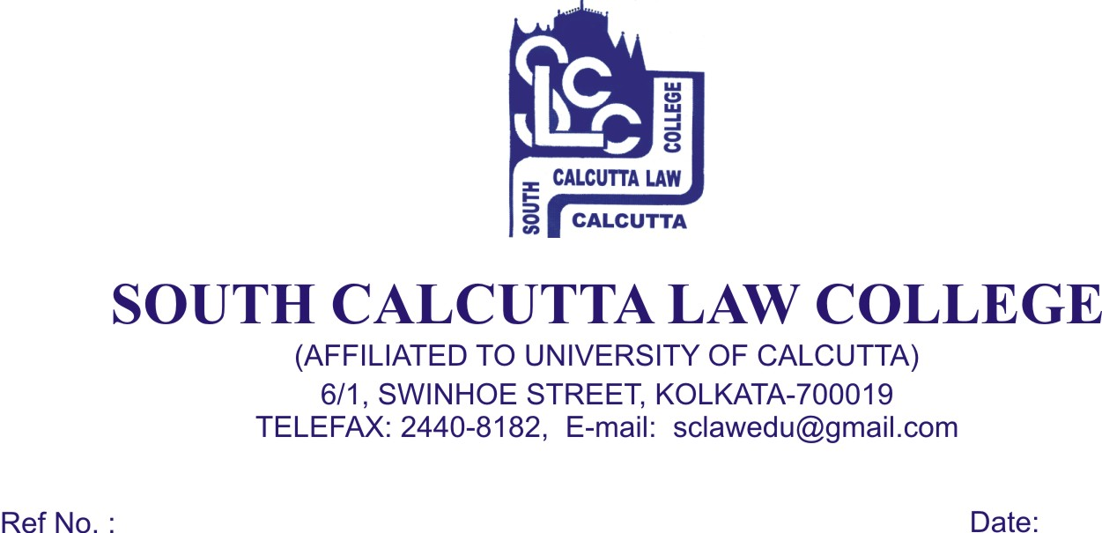

NOTICE
Date - 24/03/2018

Students of 1st, 5th, 7th and 9th Semester along with Honours Candidates B.A.LL.B (5 years course), General & Hons. Examination, 2017 are hereby informed that Admit Card will be issued on 26.03.2018 (Monday) and 27.03.2018 (Tuesday) from 09.00 a.m. to 12.00p.m.

The above dates which are finalized for issuance of Admit Card are mandatory.

No Candidates will be entertained after 27.03.2018 (Tuesday) and without the ‘FEES CARD’.

Dr. Debasis Chattopadhyay
Principal

