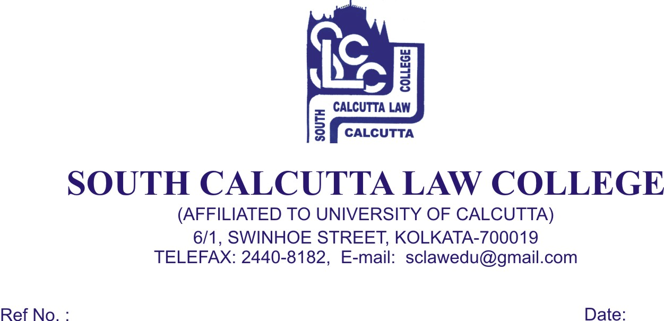
NOTICE
Date – 10/02/2018

Students of 2nd Semester, 4th Semester, 6th Semester and Honours. and General Candidates, 8th Semester and Honours. and General Candidates of B.A.LL.B (5 year course), Examination, 2018 are hereby notified that issuance and submission of ‘Review Form’ will be conducted in the office room on 13th February, 2018 (Tuesday), 15th February 2018 (Thursday) and 16th February 2018 (Friday) from 09.00 a.m. to 11.00 a.m. respectively along with Re – examination Fees of Rs.110/- (Rupees One Hundred and Ten) only for 1(One) Paper and Rs. 220/- (Rupees Two Hundred and Twenty) only for 2 (Two) papers.

All students are required to bring the photocopies of last Semester mark sheet.

No Candidates will be entertained after 16.02.2018 and
without the ‘FEES CARD’.

Interested Students Contact Mr. Raju Kahar in the office room immediately.

Dr. Debasis Chattopadhyay
Principal

