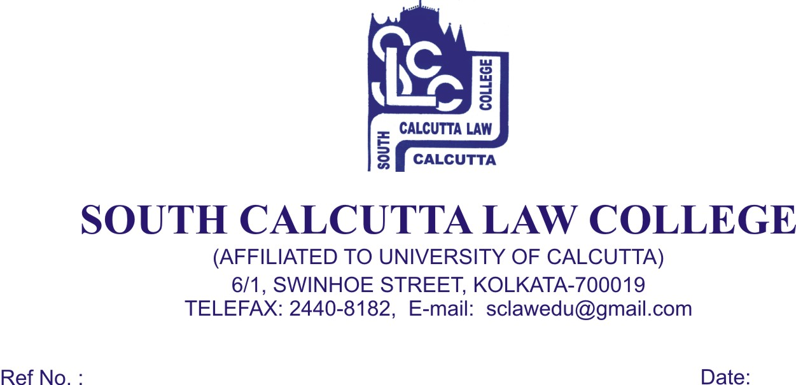

NOTICE
Date – 10/02/2018

Students of 2nd Semester, 4th Semester, 6th Semester and Honours. and General Candidates, 8th Semester and Honours. and General Candidates of B.A.LL.B (5 year course), Examination, 2018 are hereby notified that Mark sheets will be issued on 12th February, 2018 (Monday) and 13th February, 2018 (Tuesday) from 09.00a.m. to 11.30 a.m. respectively.

All students are required to bring the ADMIT CARD and FEES CARD.

No Candidates will be entertained
after the above mentioned dates.

Dr. Debasis Chattopadhyay
Principal

