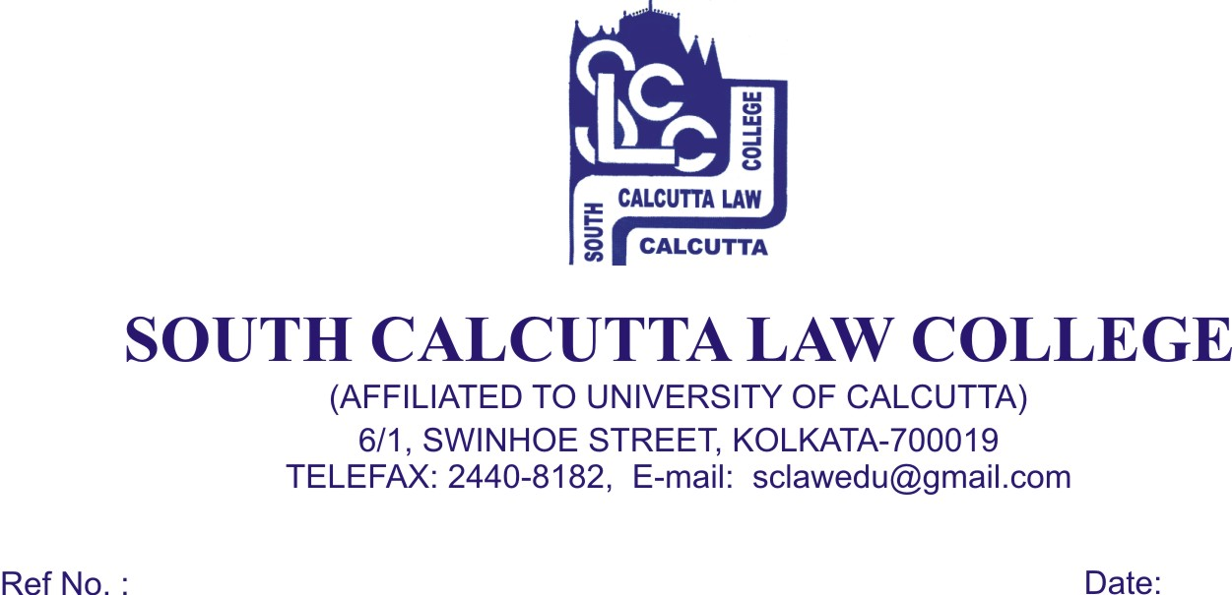
NOTICE

Date – 20/11/ 2017

Students of 1st (First) Semester (Admission 2017) are hereby informed that ‘Check – List’ fill up is Mandatory for “Students Particulars of 1st Semester 5 (Five) Year B.A. LL.B. Examination” will be conducted on 23rd November, 2017, Thursday and 24th November, 2017, Friday from 09.30 a.m. to 11.30 a.m. along with these following Original documents :

- 1 (One) stamp size photo (mandatory) [No pair of scissors will be used to cut large photo as per the direction of the Calcutta University, otherwise ‘Check – List’ will be cancelled]
- H.S. (10+2) Admit Card & H.S. (10+2) Mark Sheet
- Madhyamik Admit Card & Mark Sheet for Date of Birth proof
- Calcutta University Registration Certificate (if applicable)

- All Students are needed to bring their Original Testimonials as mentioned above and need to produce the Originals at the time of ‘Check – List’ fill up.

- No candidates will be entertained after the above mentioned dates as per the direction of the Calcutta University, otherwise ‘Check – List’ will be cancelled

Dr. Debasis Chattopadhyay
Principal

