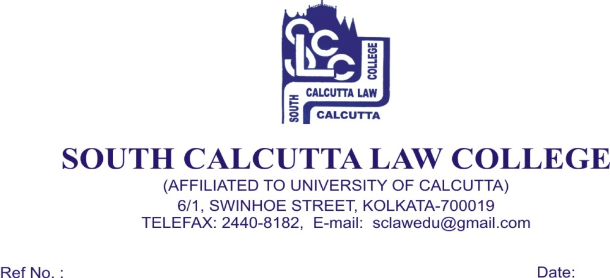

Notice
23-08-2017

Students of all semesters are hereby notified that they have to pay their session charges for the Academic Year 2017-2018 before the issue of Admit Card. Students will not be issued their Admit Cards if they fail to pay their session charges within the due date.

(Dr. Debasis Chattopadhyay)
Principal

