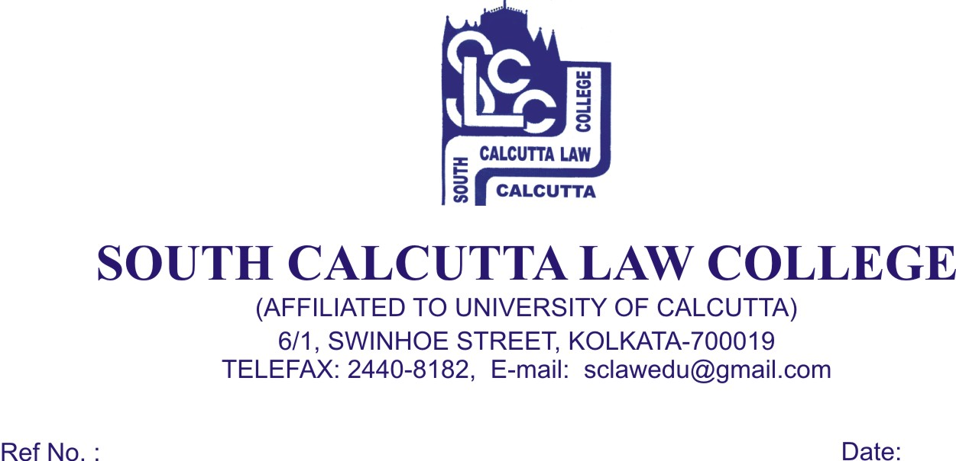
NOTICE

Date – 29/07/ 2017

Students of 1st (First) Semester (Admission 2017) are hereby informed to apply for their C.U. Registration Forms from the College Office immediately on 17th August, 2017, Thursday, 18th August, 2017, Friday and 19th August, 2017, Saturday from 09.00 a.m. to 11.00 p.m. along with these following documents :

- Photocopy of Admit Card of B.A.LL.B. entrance test, 2017
- Photocopy of H.S. (10+2) Admit Card
- Photocopy of H.S. (10+2) Mark Sheet
- Photocopy of Madhyamik Admit Card for Date of Birth proof
- Two (2) stamp size photo
- In case of Migration Students, Original Migration Certificate is required
- Photocopy of S.C., S.T., O.B.C., and P.W.D. Certificate
- Photocopy of Aadhaar Card
- Photocopy of BPL/APL card

- Registration Fees (Non – Migration) ----- Rs. 250/- (Rupees Two Hundred and Fifty) only
- Registration Fees (Migration) ----- Rs. 350/- (Rupees Three Hundred and Fifty) only

Students are also required to mentioned their Joint entrance 2017 Roll No and Rank on all their photocopies.

Registration Form and Migration Form will be collected from the Office of South Calcutta Law College, 6/1 Swinhoe Street, Kolkata - 700 019

Dr. Debasis Chattopadhyay
Principal

