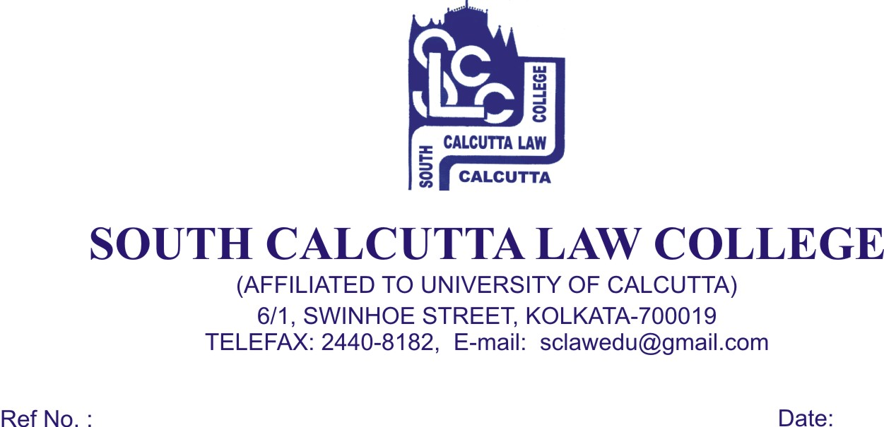

NOTICE
Date - 07.08.2017

Students of 1st (First) semester (Admission 2017) are hereby informed that their classes will start from 9th August, 2017 (Wednesday) at 6.30 a.m. and Guardian meeting(1st Semester) will be held in same day at 9 a.m. All guardian must present at the meeting.

Dr. Debasis Chattopadhyay
Principal

