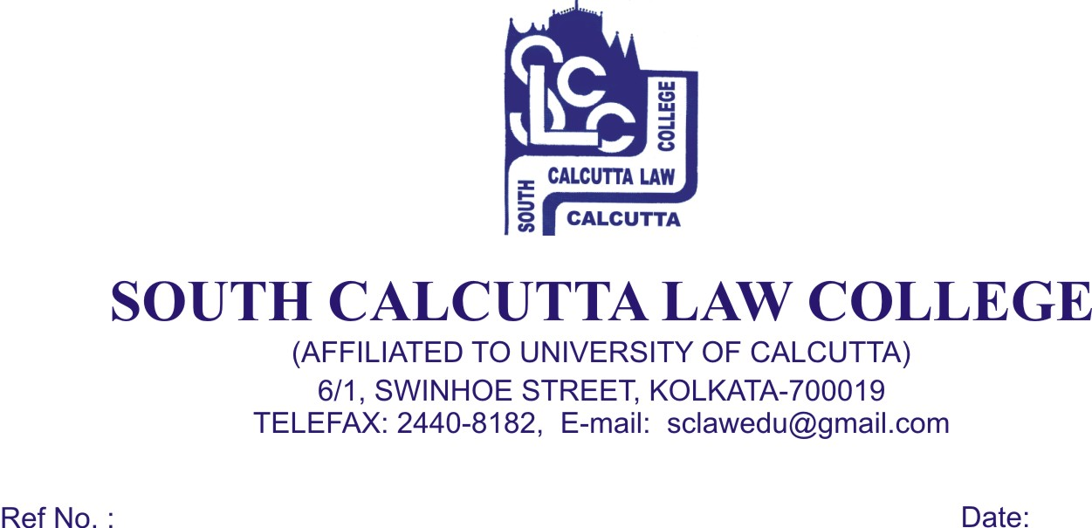
NOTICE
Date – 12.07.2017

Viva – Voce Examination for 10th Semester Students will be held on 18th July, 2017, Tuesday, 19th July, 2017, Wednesday and 20th July, 2017, Thursday. Students must bring their Original Admit Card of 10th Semester and Registration Certificate. They must be in Black & White Uniform and report in the College at 7.45 a.m. Viva – Voce will start from 8.00 a.m. onwards.
Sl. No | DATE |  | C.U. ROLL NO | TOTAL NO OF CANDIDATES
1. | 18.07.2017 (TUESDAY) |  | L04/LLB/121300  TO  L04/LLB/121373  and  L04/LLB/111601  &  L04/LLB/111538 | 62
2. | 19.07.2017 (WEDNESDAY) |  | L04/LLB/121375  TO  L04/LLB/121525 | 60
3. | 20.07.2017 (THURSDAY) |  | L04/LLB/121533  TO  L04/LLB/121758  AND  ALL HONOURS CANDIDATES | 60  &  Rest
Dr. Debasis Chattopadhyay
Principal

