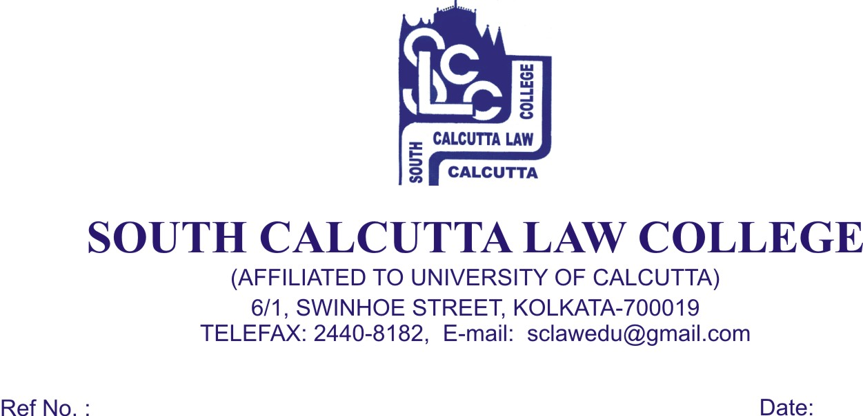
NOTICE
Date - 23/06/2017

College will remain closed on 26th June, 2017, Monday and 27th June, 2017, Tuesday on the occasion of EID-UL-FITR and re-open on 28th June, 2017, Wednesday.

Dr. Debasis Chattopadhyay
Principal

