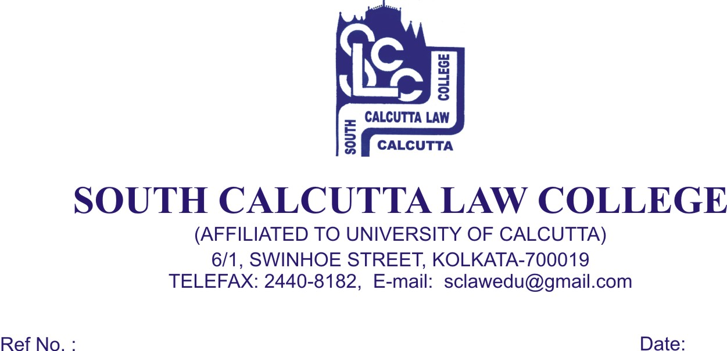

N.S.S Special Camp

This is hereby informed to all N.S.S Volunteers that South Calcutta Law College is going to organize its 7 days 4th National Service Scheme Special Camp on and from 15 February to 22nd February, 2017].

You presence in the camp is compulsory all of you are directed to attend the meeting on 13th February, 2017 Monday at 10.30 a.m.

Dr. Debasis Chattopadhyay
Princiapl

